**Test**

**Discipline Document**

**I-3 Analysis and Software Design**

**Project: HHS Term Planning**

**Date: 19-03-2014**

**Owner: Gideon Kuijpers, Gary Haime**

**Version: 0.1**

**Document History**

**Revision History**

|  |  |  |
| --- | --- | --- |
| **Version** | **Revision date** | **Summary of changes** |
| 0.1 | 19-03-2014 | Introduction of the test discipline is added. |
| 0.2 | 20-03-2014 | TRA is added. |
| 0.3 | 25-03-2014 | Master test plan is added. |
| 0.4 | 02-04-2014 | Detail Test plan is added. |
| 1.0 | 10-04-2014 | Test design and intake testbase are added. |

**Approvals**

This document requires the following approvals.

|  |  |  |  |  |
| --- | --- | --- | --- | --- |
| **Version** | **Name** | **Function** | **Date of approval** | **Signature** |
|  |  |  |  |  |
|  |  |  |  |  |
|  |  |  |  |  |
|  |  |  |  |  |
|  |  |  |  |  |
|  |  |  |  |  |

**Distribution**

This document is intended for:

|  |  |  |  |
| --- | --- | --- | --- |
| **Name** | **Function** | **Date of issue** | **Version** |
| Wim Lustenhouwer | Project Manager | 10-04-2014 | 1.0 |
| Djastin van Damme | Co-Project Manager | 10-04-2014 | 1.0 |
| Gideon Kuijpers | Test manager | 10-04-2014 | 1.0 |
| N.N. | Test manager India | 10-04-2014 | 1.0 |
|  |  |  |  |
|  |  |  |  |
|  |  |  |  |

**Table of Contents**

**1. Introduction**

**2. Test Risk Analysis**

2.1 Identifying the stakeholders and the kick-off

*2.1.1 Stakeholders*

*2.1.2 Kick-off*

2.2. Determine functions and areas of importance

2.3 Determine relative importance

2.4 Process Data

**3. Master Test Plan**

3.1 Task Description

*3.1.1 Test project name*

*3.1.2 Project summary*

*3.1.3 Anticipated Results*

*3.1.4 Customer*

*3.1.5 Accepter*

*3.1.6 Scope*

*3.1.7 Test level*

*3.1.8 Expected end date / available budget*

*3.1.9 Task description*

*3.1.10 Agreements on reporting*

3.2 Test base

*3.2.1 Introduction*

*3.2.2 Documents*

*3.2.3 Application*

*3.2.4 Test ware*

3.3 Test Strategy

*3.3.1 Test approach*

*3.3.2 Risk analysis*

*3.3.3 Quality attributes*

*3.3.4 Strategy matrix*

*3.3.5 Test environment*

*3.3.6 Assuring the quality of the test project*

*3.3.7 Release advice*

*3.3.8 Change and Error management*

3.4 Planning

**4. Detailed test plan for system test**

4.1 Task Description

*4.1.1 Test project name*

*4.1.2 Anticipated Goal*

*4.1.3 Customer*

*4.1.4 Accepter*

*4.1.5 Scope*

*4.1.6 Test level*

*4.1.7 Expected end date / available budget*

*4.1.8 Task description*

*4.1.9 Agreements on reporting*

4.2 Test Base

*4.2.1 Introduction*

*4.2.2 Documents*

*4.2.3 Application*

*4.2.4 Test ware*

4.3 Test Strategy

*4.3.1 Test approach*

*4.3.2 Risk analyses*

*4.3.3 Quality attributes*

*4.3.4 Strategy matrix*

*4.3.5 Test techniques matrix*

*4.3.6 Test environment*

*4.3.7 Assuring the quality of the test project*

*4.3.8 Release advice*

*4.3.9 Change and Error management*

4.4 Planning

4.5 Sanity check report

**5. Test design**

**1. Introduction**

The purpose of this document is to describe the test approach and test methods chosen for this project. This document consists of five different components:

* The risk analysis: an overview of the components contained within the system and an analysis of their risk-sensitivity.
* The master test plan: outlines the test approach and gives a global view on how the tests will be enacted.
* The detailed test plan: deepens the master test plan. It gives a more complete description of how the system will be tested, which tests will be used and how they will be executed.
* The sanity check report: contains the data used as the test base.
* Test design: contains all high priority test designs.

**2. Test Risk Analysis**

**2.1 Identifying the stakeholders and the kick-off**

**2.1.1 Stakeholders**

The client expects a term planning application that is less time consuming and more efficient that the currently used system. For more information, check the PID and Requirements Discipline document.

By performing a 1-D test risk analysis, the important areas of the system are identified, after which the test depth and the order of performing tests are determined.

The project’s stakeholders:

* Jos van Aalten (general manager Academy for IT & Media)
* Erik van Dordrecht (team manager at the Academy for IT & Media)
* Josine (course manager at the Academy for IT & Media)
* Thea (teacher at the Academy for IT & Media)

**2.1.2 Kick-off**

To determine the test depth and the order of performing the tests a test risk analysis (TRA) is needed. Usually the stakeholders would be invited for a TRA session, but this project is organised in such a way that would make this impossible. The information needed to perform a TRA session was given too late. We only had one day to prepare for the TRA. Therefore the following input is used instead of the output of the TRA:

* Prioritized requirements as described in the Requirements Discipline.
* Use case specifications as described in the Requirements Discipline.
* Processes described in the Business Modelling Discipline.

**2.2. Determine functions and areas of importance**

To determine the risk areas of the system and its functions a test tree has been made. The left branch of the test tree describes the most important quality attributes of the system, in accordance with the ISO 9126 norms. The right side describes the functions of the system grouped by subsystem.

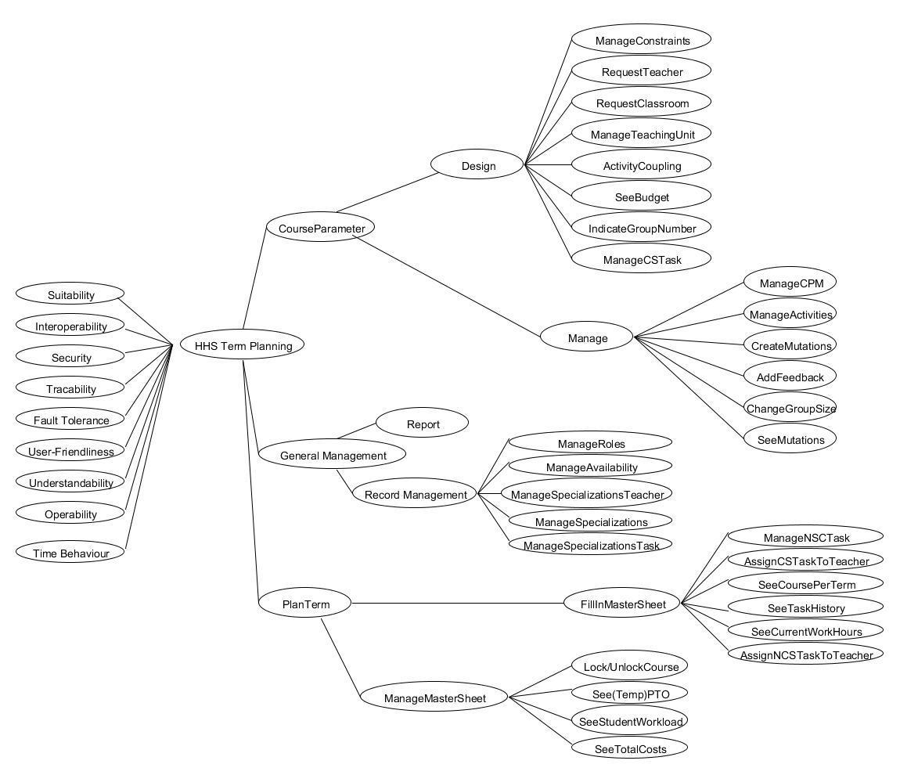

**2.3 Determine relative importance**

In this chapter the importance of each risk area from the test tree will be prioritized by the test manager and test coordinator. Both will divide 110 points among the risk areas to prioritize them.

The following point system is used:

* 9 points: crucial, the system cannot function without these elements
* 5 points: important, the system can still function if a workaround or quick fix is available
* 3 points: non crucial, the system can still function without these elements but testing is preferred
* 1 point: non important, the system will fully work without these elements

|  |  |  |
| --- | --- | --- |
| **Risk area** | **Test Coordinator** | **Test Manager** |
| CourseParameter -> Design -> ManageConstraints | 5 | 3 |
| CourseParameter -> Design -> RequestTeacher | 3 | 1 |
| CourseParameter -> Design -> RequestClassroom | 3 | 1 |
| CourseParameter -> Design -> ManageTeachingUnit | 3 | 3 |
| CourseParameter -> Design -> ActivityCoupling | 1 | 1 |
| CourseParameter -> Design -> SeeBudget | 1 | 3 |
| CourseParameter -> Design -> ManageCSTask | 5 | 5 |
| CourseParameter -> Design -> IndicateGroupNumber | 1 | 3 |
| CourseParameter -> Manage -> ManageCPM | 9 | 9 |
| CourseParameter -> Manage -> ManageActivities | 5 | 5 |
| CourseParameter -> Manage -> CreateMutations | 3 | 5 |
| CourseParameter -> Manage -> AddFeedback | 1 | 3 |
| CourseParameter -> Manage -> ChangeGroupSize | 3 | 3 |
| CourseParameter -> Manage -> SeeMutations | 1 | 5 |
| General Management -> Record Management -> ManageSpecilizationsTeacher | 5 | 3 |
| General Management -> Record Management -> ManageSpecilizations | 1 | 1 |
| General Management -> Record Management -> ManageSpecilizationsTask | 5 | 3 |
| General Management -> Record Management -> ManageAvailability | 3 | 5 |
| General Management -> Record Management -> ManageRoles | 5 | 5 |
| PlanTerm -> FillInMasterSheet -> ManageNCSTask | 3 | 5 |
| PlanTerm -> FillInMasterSheet -> AssignCSTaskToTeacher | 9 | 9 |
| PlanTerm -> FillInMasterSheet -> SeeCoursePerTerm | 3 | 3 |
| PlanTerm -> FillInMasterSheet -> AssignNCPTaskToTeacher | 9 | 9 |
| PlanTerm -> FillInMasterSheet ->  SeeCurrentWorkHours | 5 | 3 |
| PlanTerm -> FillInMasterSheet -> SeeTaskHistory | 3 | 5 |
| PlanTerm -> ManageMasterSheet -> See(temp)PTO | 5 | 5 |
| PlanTerm -> ManageMasterSheet -> Lock/UnlockCourse | 3 | 3 |
| PlanTerm -> ManageMasterSheet -> SeeStudentWorkload | 3 | 1 |
| PlanTerm -> ManageMasterSheet -> SeeTotalCosts | 3 | 1 |

**2.4 Process Data**

The risk areas of the system are categorized by the points given in the risk area analysis. These categories are as follows:

* Critical, the 10% extremely important risk fields
* High, the 20% more important risk fields
* Medium, the 30% less important risk fields
* Low, the 40% least important risk fields

The calculation is specified in the Test Risk Analysis of the MTP and in their respective detailed test plans.

**3. Master Test Plan**

**3.1 Task Description**

**3.1.1 Test project name**

Term planning Test project (TP2).

**3.1.2 Project summary**

The objective of the master test plan (MTP) is to give structure to the test process and make sure everyone involved in the test process is on the same page.

The master test plan describes the test approach, activities and (end) products that will require further elaboration in the detailed test plans.

**3.1.3 Anticipated Results**

The client expects that the currently used system to design courses and plan terms is replaced by a new system that meets the following criteria:

* Increased efficiency of data processing.
* Reduction in amount of errors made by users.
* Friendlier user interface.
* Data input by the users is semi-automatic.

By meeting the criteria mentioned above, the users of the new system should be able to plan terms in less time than before *and* with less errors due to manual input.

The test process will guarantee that the system meets the system specifications, as specified within the requirements, by giving insight about approach, activities and products to be delivered.

The Master Test Plan delivers the activities needed to ascertain these specifications are met. This concludes in the ultimate goal; Assuring the quality of the product.

**3.1.4 Customer**

The customer of this project is the client, Jos van Aalten.

**3.1.5 Accepter**

The acceptors of this project are Gideon Kuijpers (test manager) and Gary Haime (test coordinator).

**3.1.6 Scope**

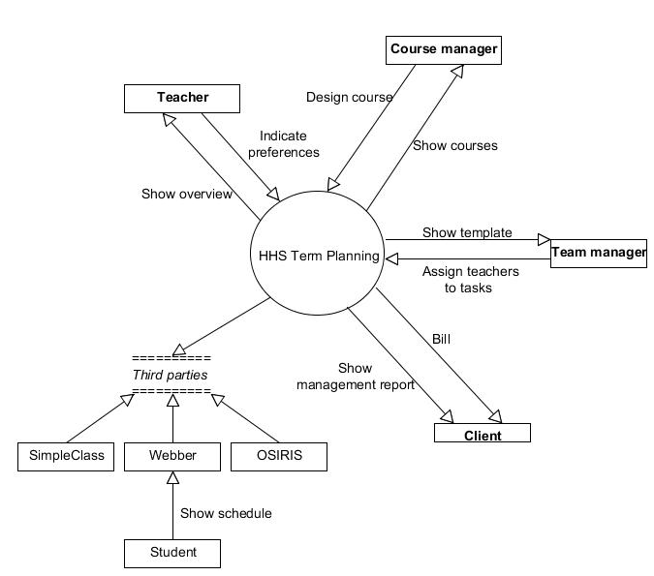

The system's main aim is to plan courses within specified terms. When which course will run is specified in the year plans of the academy for IT & Media.

The process can be divided in five processes: create a year plan, design a course, plan a term, create a schedule and realise a course, as described in the business modelling discipline.

The system focus lays with two of these processes: design a course plan and plan a term. These two will be fully evaluated for testing.

Creating a year plan falls fully outside of scope. The scheduling process is done externally but the communication needed, will be tested.

Realising a course results in adding feedback which is done in our system and will therefore be also evaluated for testing.

**3.1.7 Test level**

The test levels that are used within the project are Module test, Module-integration test, System test, chain test and acceptance tests concerning the user and functionality. The mentioned test are used because of the following reasons:

* Module/module-integration test must ensure that the modules to design a course plan and to plan a term work according to technical design and work together correctly.
* System test will ensure that the HHS Term Planning system works as functional designed.
* Chain test must ensure that the HHS Term Planning system works together with the scheduling department.
* Acceptance test must be performed to ensure that the system meets the specifications of the requirements and is in accordance with the wishes and demands of the client.

**3.1.8 Expected end date / available budget**

The deadline is 10-04-2014. By then the documentation is to be delivered to the client of this project and the tests must be ready to be executed. The available budget(in hours) for test-planning, divided over a three week period is approximately 60 hours.

These 60 hours are taken with the multiple disciplines of team members in consideration.

After test planning, the coding team needs to design tests. Designing the several tests is a time-consuming activity which by could take up to 200 hours. These hours are taken based on assumption and should be evaluated between the coding team and the client.

Advice for a realisation-budget of tests is 250 hours, which should be executed before the construction phase end-date. Reaching a total test budget of 510 hours.

**3.1.9 Task description**

The client has an application, which is responsible for planning, assigning and scheduling the tasks of the teachers of the Academy for IT & Media. The whole process takes about 900 hours. The client thinks this could be done more efficiently. He wants it to be optimized. The new application should be able to do the process within 780 hours.

According to customer the project can be called a success when the following expectations are acquired:

* The client can perform the process of planning assigning, scheduling and evaluating terms in 780 hours per term.
* The client can generate management reports, which contain information about deploying of teachers and data on the available expertise and expertise needed in the future.
* The above-mentioned process contains less faults.

For the MTP to be called a success:

* The MTP provides sufficient information to form detailed test plans.
* MTP contains guidelines on all tests to be executed.

**3.1.10 Agreements on reporting**

The project lasts eight weeks. At the end of each iteration in the elaboration phase, which is every two weeks, reports per different test level is to be delivered to the client. The deliverance to the client will be done per e-mail or will be placed on the file exchange forum. The update contains information on the following data:

* results of the tests per risk category that are performed successful.
* results of the tests per risk category that are delayed or are a failure.
* Description of a test: this includes a date, costs and responsible tester.
* Quality of the test: insight is given by looking at the results of the tests per risk

risk category.

* Release advice

To ensure the client’s satisfaction, delivering data on tests is a requisite. This serves as a measurement for the project’s progress. This kind of data includes the functionality.

**3.2 Test base**

**3.2.1 Introduction**

The test base describes the documents that are needed as a base for testing the test object and gives a description of on what it consist of. The documents for testing are used on different test levels. The following documents are used on the following test levels:

* Module/Module integration test: Design discipline
* System test: Analysis discipline
* FAT: Requirements & Analysis discipline
* UAT: Requirements discipline
* Chain test: Design Discipline

The various tests use the following elements to form test objects:

* GUI: the interface to access the functionalities of the new system.
* Business logic: All the core functionality within the new system.
* Data logic: All functionality concerning the database.

Together these elements form the HHS Term Planning application, which are used for testing.

**3.2.2 Documents**

|  |  |  |  |
| --- | --- | --- | --- |
| **Document name** | **version** | **date** | **status/remarks** |
| Requirements discipline | 1.3 | 28-03-2014 | UAT, final  FAT, final |
| Business Modelling discipline | 1.0 | 14-03-2014 | Final (as reference during any test) |
| Analysis discipline | 0.4 | 25-03-2014 | System test (class diagram, Sequence diagrams)  FAT(final) |
| Design discipline | 0.1 | 28-03-2014 | Module/integration (final)  Chain (final) |

**3.2.3 Application**

|  |  |  |  |
| --- | --- | --- | --- |
| **Application name** | **version** | **date** | **status/remarks** |
| HHS Term Planning |  |  | system to be build |
| Term Planning mail plug-in Scheduling Department |  |  | During and after construction of code that handles scheduling department connection. |
| SQL Database | 1.0 | t.b.d. |  |

**3.2.4 Test ware**

|  |  |  |  |
| --- | --- | --- | --- |
| **Test ware** | **version** | **date** | **status/remarks** |
| Detailed Test plan system test | 1.0 |  |  |
| Master Test plan | 1.0 |  |  |

**3.3 Test Strategy**

**3.3.1 Test approach**

The time to perform testing on the system is limited; not everything can be tested because of this reason. So choices have to be made. There has been striven to divide the test capacity as effective and efficiently as possible about the whole test section. This is further described in the remaining test strategy.

The test strategy is risk-based. This means that the new system is built well enough to guarantee that there will be no major risks for the Hague University. Areas of the system that are categorized as major risks will be tested thoroughly.

The first step of determining the test strategy was the above 1-D risk analysis. Afterwards the test strategy is determined on the outcome of this analysis. The strategy describes what and how there will be tested by the team and is focused on finding major risks at an earlier stage of the project so it will cost the client less money.

**3.3.2 Risk analysis**

On 20-03-2014 the following people carried out a risk analysis:

* Gideon Kuijpers, Test manager
* Gary Haime, Test coordinator

The following risks and their significance are acknowledged:

|  |  |  |
| --- | --- | --- |
| **Risk category** | Risk area | Relative importance |
| **Critical** | CourseParameter-Manage-ManageCPM | 18 |
|  | PlanTerm-FillInMasterSheet-AssignCSTaskToTeacher | 18 |
|  | PlanTerm-FillInMasterSheet-AssignNCPTaskToTeacher | 18 |
| **High** | CourseParameter-Manage-ManageActivities | 10 |
|  | CourseParameter-Design-ManageCSTask | 10 |
|  | General Management-Record Management-ManageRoles | 10 |
|  | PlanTerm-ManageMasterSheet-See(temp)PTO | 10 |
| **Medium** | CourseParameter-Design-ManageConstraints | 8 |
|  | General Management-Record Management-ManageSpecilizationsTeacher | 8 |
|  | General Management-Record Management-ManageAvailability | 8 |
|  | PlanTerm-FillInMasterSheet-ManageNCSTask | 8 |
|  | PlanTerm-FillInMasterSheet-SeeCurrentWorkHours | 8 |
|  | PlanTerm-FillInMasterSheet-SeeTaskHistory | 8 |
|  | General Management-Record Management-ManageSpecilizationsTask | 8 |
|  | CourseParameter-Design-ManageTeachingUnit | 6 |
|  | CourseParameter-Manage-CreateMutations | 6 |
|  | CourseParameter-Manage-ChangeGroupSize | 6 |
|  | CourseParameter-Manage-SeeMutations | 6 |
|  | PlanTerm-FillInMasterSheet-SeeCoursePerTerm | 6 |
| **Low** | CourseParameter-Design-RequestClassroom | 4 |
|  | CourseParameter-Design-SeeBudget | 4 |
|  | CourseParameter-Design-IndicateGroupNumber | 4 |
|  | CourseParameter-Manage-AddFeedback | 4 |
|  | PlanTerm-ManageMasterSheet-Lock/UnlockCourse | 4 |
|  | PlanTerm-ManageMasterSheet-SeeStudentWorkload | 4 |
|  | PlanTerm-ManageMasterSheet-SeeTotalCosts | 4 |
|  | General Management-Record Management-ManageSpecilizations | 2 |
|  | CourseParameter-Design-ActivityCoupling | 2 |

**3.3.3 Quality attributes**

|  |  |
| --- | --- |
| **Quality attributes** | **Significance**  **H M L N** |
| **Functionality**  Suitability  Accuracy  Interoperability  Compliance  Security  Traceability | * + x M x x   + x x x N   + x x L x   + x x x N   + H x x x   + x M x x |
| **Reliability**  Maturity  Fault tolerance  Recoverability  Availability  Degradability | * + x x x N   + x M x x   + x x x N   + x x x N   + x x x N |
| **Usability**  Understandability  Learnability  Operability  Explicitness  Customisability  Attractivity  Helpfulness  User-friendliness | * + x M x x   + x x x N   + x M x x   + x x x N   + x x x N   + x x x N   + x x x N   + H x x x |
| **Efficiency**  Time behaviour  Resource behaviour | * + x x L x   + x x x N |
| **Maintainability**  Analysability  Changeability  Stability  Testability  Manageability  Reusability | * + x x x N   + x x x N   + x x x N   + x x x N   + x x x N   + x x x N |
| **Transferability**  Adaptability  Installability  Conformance  Replaceability | * + x x x N   + x x x N   + x x x N   + x x x N |

**3.3.4 Strategy matrix**

|  |  |  |  |
| --- | --- | --- | --- |
| **Risk area** | **User-Friendliness** | **Fault Tolerance** | **Security** |
| *From “Quality attributes” table* | H | H | M |
| Module test/integration test | - | H | - |
| System test | - | M | M |
| Functional acceptance test | - | - | M |
| User acceptance test | H | - | - |
| Chain test | - | M | - |

|  |  |  |  |
| --- | --- | --- | --- |
| **Risk area** | **Suitability** | **Operability** | **Interoperability** |
| *From “Quality attributes” table* | M | M | M |
| Module test/integration test | - | L | M |
| System test | M | - | - |
| Functional acceptance test | H | - | - |
| User acceptance test | - | H | - |
| Chain test | - | - | H |

|  |  |  |  |
| --- | --- | --- | --- |
| **Risk area** | **Traceability** | **Understandability** | **Time Behaviour** |
| *From “Quality attributes” table* | M | M | L |
| Module test/integration test | - | - | - |
| System test | M | L | - |
| Functional acceptance test | H | - | L |
| User acceptance test | - | H | - |
| Chain test | - | - | - |

H=high, M=medium, L=low, N= not relevant

The subcategories of the quality attributes, maintainability and transferability are not taken into account as the stakeholders did not mention any of the points belonging to this two points. As the previous sections show, the most important aspects are that the key functionalities work without flaws and that the new system is usable. As such user-friendliness, understandability and operability get a high priority in the user acceptance test and fault tolerance gets a high priority in the module/integration and medium priority in the system and chain test to discover faults at an early stage to reduce the costs. Security is to gets a medium priority because other people than the stakeholders should not be able to use the system. Also the speed of the system is to be tested. Though this has a low priority due the fact speed is not an issue nowadays.

**3.3.5 Test environment**

The Hague University employs several windows operated pc’s. These pc’s are connected to the internet and have no specific intranet. These pc’s are connected to a main server, all software desktops are launched through these servers through a login system.

Teachers and students all have individual logins, with corresponding roles attached to them. Their respective desktops have restraints to downloading and installing software.

The test environment for the new system should be similar to the environment the Hague University uses as described above.

Furthermore the environment should be able to adapt to the different kinds of tests that will be performed. The following section describes which tools are needed for which kind of test:

* Module /integration test : The environment for this test should at least contain a database, Unit test-tool, stubs and drivers to simulate missing modules needed for the test, test data, data registration tool and version control tool.
* System test: the environment for this test should contain a database, write-only and login rights to the used database, test data, stubs and drivers, test tool, and a data registration tool.
* Functional acceptance test: the environment should contain a database, a test tool , a data registration tool and test data.
* User acceptance test; the environment should contain a simulator the simulate the new system, the data registration tool and the test data.

To maintain the adaptable environments the test team made agreements about the configuration, release and back-ups of a test object. The configuration item of the different test objects must have a version number and history. Before a test object can be released it must have at least a conditional release advice and there are no major concerns described in the release notes. Also, before a new version can be uploaded to the test environment, a back-up has to be made.

**3.3.6 Assuring the quality of the test project**

The quality of the test project shall be assured in the following ways:

* Intakes: In order to ascertain the quality of the test bases a sanity check shall be performed. The results of this check shall either show that the test bases have enough quality to be used as test bases or whether they should be modified and, if so, in what way.
* Review of the test designs: by reviewing the test design documents, the stakeholders can be given insight about the test procedure. By doing this the team can make sure the stakeholders are aware of the choices made and if needed will intervene. This will also make sure that any forgotten risks will be brought forward if the stakeholders miss them.
* Reviewing test ware: once a certain type of test has been done certain parts can be reused for other tests. These are called the test ware and are used to increase efficiency. However in order to maintain an effective way of testing the test ware needs to be reviewed if it is indeed applicable for the next test(s). The development team can advice if this is necessary.

**3.3.7 Release advice**

In the project there are three possible release advices. A release advice can be positive, conditional or negative. These can be characterized as followed:

* positive: is given when the functions, defined as a high or middle risk contain no major risks and ones with a low risk are at least functional.
* conditional: is given when there are still bugs in some functions of the tested area. but they do not possess a threat to the system. This bugs can be fixed a next time.
* negative: is given when multiple function, which were tested, contain majors issues. In this case the test team mentions to the developers which parts were tested negative.

A release advice is given at the end of a test cluster by the test manager, which the name indicates, is merely an advice. This advice will be based on the product status in proportion to the envisioned result. Relevant factors in this comparison are remaining product risks, the yet to be executed tests and the gap between the striving quality and the realised quality.

Afterwards the test manager comes with recommendations to get a positive advice. The final decision of whether a function should be implemented will be made by the client.

**3.3.8 Change and Error management**

To guarantee the quality of the system adaptation and how changes in the sanity check are handled. This also applies to findings and new releases.

Adaptations in the sanity check are handled by a meeting between the responsible parties.

Minor changes can be made directly in the test design. For changes of bigger impact, a change request has to be submitted. The project manager will then weigh the pros and cons and come to his decision. This will be done by the hand of the reason, benefits, details and costs.

To handle findings the tester that finds, one is asked to register the findings in the findings registration tool. This registration contains the following data:

* identifier
* date
* name of tester
* status
* risk
* release version
* summary
* description

After registration, the test coordinator within the team in India checks if the above-mentioned process has been completed correctly. Then a review is hold to discuss the findings, which are open, new or solved, and the team comes up with a solution for certain findings. Afterwards a developer is to program the solution and the tester that did the finding must test if the solution is successful.

After the findings and changes/errors are processed, releases are planned through a dialog between the test coordinator and the project manager. In this dialog the test coordinator of the team gives an indication of when the test object should be released. The project manager gives a time indication of how long it takes to bring out the release. Afterwards the release is reviewed with the stakeholder.

**3.4 Planning**

Throughout the Inception and Elaboration phases, documentation and designs are tested by the client and the stakeholders to ensure all documents are sufficient.

During the construction phase, the code is divided into six packages. At the end of construction of such a package, the coding team has 4 hours at the end or construction to perform the module test and another 4 hours to perform integration test. As results of these test can be negative or inconclusive, these tests may have to be redone after code has been edited.

The module tests may be done three times and the integration tests five times resulting in a budget of (4x3 + 4*5) 32 hours. The project group advices to save time for after the system test as coding may need to be edited after the system test.

System testing is performed when the code in alpha phase and is expected to take 20 hours. After the system test, the functional acceptance test can be performed. As much of the functional acceptance testing is performed during the system test, this should take 10 hours total.

The user acceptance test takes 2 hours per iteration, and is performed at the end of the construction phase. This can be performed up to 8 times resulting in a budget of (2x8) 16 hours.

The total budget concludes as (32+20+10+16) 78 hours. And is performed during the construction phase.

**4. Detailed test plan for system test**

**4.1 Task Description**

**4.1.1 Test project name**

TP2 system test

**4.1.2 Anticipated Goal**

As mentioned in the master plan, the goal for the system test is to ascertain the application works as designed. This test is executed in the construction phase and will be used to test the completed code and to ensure said code is cohesive and functional.

With code fully functional and tested, the results of this test is used in conjunction with the functional acceptance test to ensure the application works as intended by the project team, with approval and understanding from the HHS.

The results of these test help to complete two of the goals from the master test plan:

* Increased efficiency of data processing and reducing errors.
* Data input by the users is semi-automatic.

As the master test accumulated in assuring the quality of the product, we must test the quality of the requirements and design documents. When these requirements are met, we can conclude that the TP2 System test base is of sufficient quality. As a result, the TP2 system test ascertain the quality of the system. This means that the code and functionalities meet the quality expectations.

The goal for TP2 System test can be described as ascertaining this quality, helping the goal for the master test plan.

**4.1.3 Customer**

The customer is of the project is client, Jos van Aalten.

**4.1.4 Accepter**

Gideon Kuijpers(Test Manager), Gary Haime(Test Coordinator).

**4.1.5 Scope**

The system will be tested from it’s first alpha phase. The system test wil be based on the requirements as specified in the requirements discipline document.

Code and functionality dealing with external communications are part of chain testing and falls out of scope of system testing. As such, the coupling with the scheduling department will not be tested with the system test. Likewise for acceptance of the year planning.

Feedback functions as described in realising a course from the master plan will be tested.

**4.1.6 Test level**

System test

**4.1.7 Expected end date / available budget**

System test should costs 20 hours(times modal Indian programming wages) maximum with the end date in mind. This plan has been conceived on the basis of two test workers(test manager, and test coordinator).

**4.1.8 Task description**

The system test starts when the code reaches alpha phase. Using the requirements discipline document as a base, all elements will be checked to see if the built application produces the required results. Checked elements can result in a positive result when the requirements are available and functional as described.

If any functionality is missing, the test will be considered to have negative results and the construction should continue to add the missing feature(s).

TP2 system test can be called a success when all requirements and documents have been tested. However, TP2 system test needs to be reused until all results are positive in order. As such, the goals of the test are met when all results are positive.

**4.1.9 Agreements on reporting**

Reporting will be happening as stated in the description of the Agreements on reporting in the Master test plan. But instead of reporting to the client there will be reported to the test coordinator responsible for the detailed test plan.

**4.2 Test Base**

**4.2.1 Introduction**

The system test will be based on the analysis discipline document. The analysis discipline document describes the general workings of the system. These general workings describe all needed functionalities in the term planning application.

Using the analysis as a base, means having all needed functionalities as reference to test the system with. Which is sufficient to clear the system tests’ goal.

**4.2.2 Documents**

|  |  |  |  |
| --- | --- | --- | --- |
| **Document name** | **version** | **status** | **Remarks** |
| Analysis discipline | 1.0 | 07-04-2014 |  |

**4.2.3 Application**

|  |  |  |  |
| --- | --- | --- | --- |
| **Application name** | **version** | **date** | **status/remarks** |
| HHS Term Planning | 1.0 | t.b.d |  |
| SQL Database | 1.0 | t.b.d. |  |

**4.2.4 Test ware**

|  |  |  |  |
| --- | --- | --- | --- |
| **Test ware** | **version** | **status** | **Remarks** |
| Module/integration test | t.b.d | executed | positive results of both |
| Master test plan | 1.0 | final | Used for general guidelines and information. |

**4.3 Test Strategy**

**4.3.1 Test approach**

The time to perform testing on the system is limited; not everything can be tested because of this reason. So choices have to be made. Because of the mentioned reason all the functionalities, within the design course, plan a term and realise a course, and quality criteria will be tested whenever they have a critical, high or medium category.

The risk categories for each functionality of quality criteria are based on the results of the test risk analysis. Functionalities and criteria are tested more intensive and with a deeper test-depth when the risk category is higher.

**4.3.2 Risk analyses**

On 20-03-2014 the risk analyse is performed by:

* Gideon Kuijpers, Test manager
* Gary Hame, Test coordinator

The following risks and their significance are acknowledged:

|  |  |  |
| --- | --- | --- |
| **Risk category** | **Risk area** | **Significance** |
| **Critical** | CourseParameter-Manage-ManageCPM | 18 |
|  | PlanTerm-FillInMasterSheet-AssignCSTaskToTeacher | 18 |
|  | PlanTerm-FillInMasterSheet-AssignNCPTaskToTeacher | 18 |
| **High** | CourseParameter-Manage-ManageActivities | 10 |
|  | CourseParameter-Design-ManageCSTask | 10 |
|  | General Management-Record Management-ManageRoles | 10 |
|  | PlanTerm-ManageMasterSheet-See(temp)PTO | 10 |
| **Medium** | CourseParameter-Design-ManageConstraints | 8 |
|  | General Management-Record Management-ManageSpecilizationsTeacher | 8 |
|  | General Management-Record Management-ManageAvailability | 8 |
|  | PlanTerm-FillInMasterSheet-ManageNCSTask | 8 |
|  | PlanTerm-FillInMasterSheet-SeeCurrentWorkHours | 8 |
|  | PlanTerm-FillInMasterSheet-SeeTaskHistory | 8 |
|  | CourseParameter-Design-ManageTeachingUni  t | 6 |
|  | CourseParameter-Manage-CreateMutations | 6 |
|  | CourseParameter-Manage-ChangeGroupSize | 6 |
|  | CourseParameter-Manage-SeeMutations | 6 |
|  | General Management-Record Management-ManageSpecilizations | 6 |
|  | General Management-Record Management-ManageSpecilizationsTask | 6 |
|  | PlanTerm-FillInMasterSheet-SeeCoursePerTerm | 6 |

**4.3.3 Quality attributes**

In the MTP, various attributes have been evaluated out of the ISO 9126. Not all quality attributes are necessary for the DTP. The following have been selected:

* Suitability: H
* Security: H
* Traceability: M
* Fault Tolerance: M
* Understandability: L

**4.3.4 Strategy matrix**

|  |  |  |  |  |  |  |
| --- | --- | --- | --- | --- | --- | --- |
| **Risk area** | **from TRA** | **Security** | **Fault tolerance** | **Traceability** | Suitability | Understandability |
| from MTP |  | H | M | M | M | L |
| CourseParameter-Manage-ManageCPM | C |  | M | L | M | H |
| PlanTerm-FillInMasterSheet-AssignCSTaskToTeacher | C |  | H |  | M | L |
| PlanTerm-FillInMasterSheet-AssignNCPTaskToTeacher | C |  | H |  | M | L |
| CourseParameter-Manage-ManageActivities | H |  | L |  | M |  |
| CourseParameter-Design-ManageCSTask | H |  | L |  | M |  |
| General Management-Record Management-ManageRoles | H | H |  | L |  |  |
| CourseParameter-Design-ManageConstraints | M |  |  |  | M |  |
| General Management-Record Management-ManageSpecilizationsTeacher | M |  | L | L | M |  |
| General Management-Record Management-ManageAvailability | M |  | L |  | M |  |
| PlanTerm-FillInMasterSheet-ManageNCSTask | M |  | L |  | M | L |
| PlanTerm-FillInMasterSheet-SeeCurrentWorkHours | M |  |  | L |  |  |
| PlanTerm-FillInMasterSheet-SeeTaskHistory | M |  |  | M | M |  |
| CourseParameter-Design-ManageTeachingUni  t | M |  | L |  | M |  |
| CourseParameter-Manage-CreateMutations | M |  | L | M | M |  |
| CourseParameter-Manage-ChangeGroupSize | M |  |  |  | M |  |
| CourseParameter-Manage-SeeMutations | M |  | L | M | M |  |
| General Management-Record Management-ManageSpecilizations | M |  | L |  | M |  |
| General Management-Record Management-ManageSpecilizationsTask | M |  | L |  | M |  |
| PlanTerm-FillInMasterSheet-SeeCoursePerTerm | M |  |  | M | M |  |

C=critical, H=high, M=medium, L=low, N= not relevant

**4.3.5 Test techniques matrix**

|  |  |  |  |  |  |
| --- | --- | --- | --- | --- | --- |
| **Risk area** | **Security** | **Fault Tolerance** | **Traceability** | **Suitability** | **Understandability** |
| CourseParameter-Manage-ManageCPM |  | Data Cycle test | Exploratory testen | CRUD | Real Life Test |
| PlanTerm-FillInMasterSheet-AssignCSTaskToTeacher |  | Algorithm: test measure 2 |  | Process  cycle test | Real Life test |
| PlanTerm-FillInMasterSheet-AssignNCPTaskToTeacher |  | Algorithm: test measure 2 |  | Process cycle test | Real Life test |
| CourseParameter-Manage-ManageActivities |  | CRUD |  | Data Cycle test |  |
| CourseParameter-Design-ManageCSTask |  | CRUD |  | Data Cycle test |  |
| General Management-Record Management-ManageRoles | C/E Graphing + Syntax |  | Exploratory test |  |  |
| CourseParameter-Design-ManageConstraints |  |  |  | Exploratory test |  |
| General Management-Record Management-ManageSpecilizationsTeacher |  | CRUD | Exploratory test | Data Cycle test |  |
| General Management-Record Management-ManageAvailability |  | Semantic test |  | Exploratory testing |  |
| PlanTerm-FillInMasterSheet-ManageNCSTask |  | CRUD |  | Data Cycle test | Use case test |
| PlanTerm-FillInMasterSheet-SeeCurrentWorkHours |  |  | Exploratory test |  |  |
| PlanTerm-FillInMasterSheet-SeeTaskHistory |  |  | Exploratory test | Real life test |  |
| CourseParameter-Design-ManageTeachingUni  t |  | CRUD |  | Data Cycle test |  |
| CourseParameter-Manage-CreateMutations |  | Semantic test | Exploratory test | Exploratory test |  |
| CourseParameter-Manage-ChangeGroupSize |  |  |  | real life test |  |
| CourseParameter-Manage-SeeMutations |  | Error guessing | Exploratory test | Exploratory test |  |
| General Management-Record Management-ManageSpecilizations |  | CRUD |  | Data Cycle test |  |
| General Management-Record Management-ManageSpecilizationTask |  | CRUD |  | Data Cycle test |  |
| PlanTerm-FillInMasterSheet-SeeCoursePerTerm |  |  | Exploratory  Testing | Real life test |  |

**4.3.6 Test environment**

For the preconditions of the test environment, look at the preconditions for the system test, described in the master test plan. To maintain this environment the configuration item record data and status of the test object, described in the scope of this plan, must updated.

Before a release can be shipped a positive release advice is to be given by the test manager and the moment for the release to be shipped must be discussed with the test coordinator. At the moment for shipping a back-up of the new version of the system is to be made and archived.

**4.3.7 Assuring the quality of the test project**

The assurance of quality of the test trajectory is guaranteed as described in the Master test plan.

**4.3.8 Release advice**

The release advice is based on the difference between the expected result and the actual that are the outcome of testing the designing, planning and realising process.

If the output between those two match and no new major risks are found in the functionalities of the design a course and plan a term process, a positive advice is given for the release system.

Under certain circumstances when the test result differ, a conditional advice is given depending on the category of the founded risk(s).

When a negative advice is given the founded risks are discussed and a solution for the risks is founded.

**4.3.9 Change and Error management**

In the test designs there will be expected results. If these results are not realised in the actual testing, that particular test will be marked as failed. In some cases the tester evaluates this failing aspect and has the ability to successfully repair it, but this will not be preferred. At such a moment, the change is not registered by a tester nor a developer, which will lead to miscommunication. However, this does not occur often. Many times it will require skilled developers to find and fix the failed part of the test by the hand of the registration tool. But these developers can’t start programming right away. The project manager will receive the failed test outcome and evaluates if it is cost-effective. When sufficiently cost-effective, the project manager gives a thumbs up, and the developers can start.

**4.4 Planning**

The master test plan prescribes 20 hours total for the system test, before 10 hours of the functional acceptance test.

Simply checking the delivered code on the presence of the requirements and the designs and sequence diagrams should take eight hours maximum. Resulting in a possible three runs of the test.

When the code first reaches alpha phase, the coding should immediately be system-tested. Results can then be handled, this will most likely result in alteration of the code and the need for new module and integration tests.

When the second run of module and integration tests have concluded, all results should prove positive. A rerun of coding and module/integration tests could be needed, making the third the definitive final run. Delivering the perfect base for the functional acceptance test.

**4.5 Sanity check report**

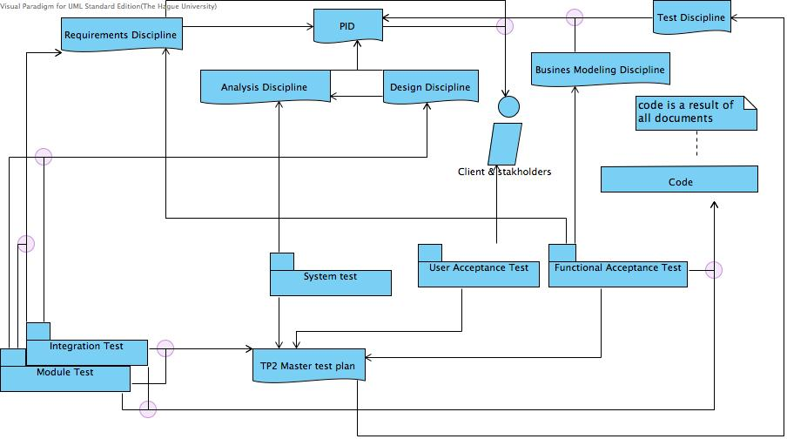

The above diagram shows the needed documents for the various tests. The PID is the basis for all documents and has been created in collaboration with the client. The PID results in five documents which have been created by the project-group and checked and approved by the client and stakeholders.

To improve the readability of the diagram, grey circles have been added to show where lines come together.

We can assume the quality of the documents is sufficient because of interviews and reviews with the client and stakeholders. As a result, the basis for the tests are assumed sufficient.

RUP system development ensures that by designing tests, any shortcomings in the base documents can still be taken care of during construction, even though the team carefully constructed all documents and tests to avoid alteration during the construction phase.

The necessary states of the documents to be suitable for testing are described in chapter test base of the TP2 master test plan.

**5. Test design**

### 

### Testdesigns ManageCPM

### Exploratory test

Goal:

the goal of this test is to verify the built components with the documentation.

Preparation:

Locate the analysis class diagram and the course template class, and the course class in chapter 3 of the analysis discipline document.

Locate the user and software requirements that specify creating, showing, and altering course designs and or parameters in chapters 3,4 and 8 of the requirements discipline document.

Locate the screen design for course management in chapter 3(paragraph 4) of the design discipline document.

Start the newest version of the HHS term planning application, and navigate to the course management screen(or other screen if the coding company has altered the designs in accordance with the client and test manager).

Implementation:

step 1:

Compare actual screen in the application with the screen from the design document. Differences should be noted as a negative test result.

step 2:

Compare editable data with data from the analysis class diagram. Missing functionalities should be noted as negative test results. Extra functionalities should be evaluated after the following step.

step 3:

compare options and possible user input and processes with the requirements from the preparation of this test. Missing options or input availabilities should be noted as negative test results. Extra options or input should be noted as negative test results. The extra functionalities from step 2 which are not noted in the requirements are also negative test results.

step 4:

Check to determine the impossibility to delete courses. When a course can be deleted. This is noted as a negative test result.

Release advice:

negative results should be evaluated with the test manager.

Negative results dealing with missing functions or options may never result in a positive release advice.

Negative results dealing with extra functions or options may result in a positive release advice if so decided by the test manager in consultancy with the client.

Specifically the negative result dealing with deleting courses must always result in a negative release advice.

### Test design ManageCPM

### CRUD& Data Cycle test ManageCPM

### Decision Coverage

|  |  |  |
| --- | --- | --- |
| **ID** | **Description** | **Source** |
| IR1-1 | Ability to edit (U) course specific tasks, if no teacher is assigned. | S04 |
| IR1-2 | Ability to edit (U) course specific tasks, if teacher is assigned. | S04 |
| IR2-3 | Ability to edit (U) course specific tasks, if no activity is assigned. | S04 |
| IR2-4 | Ability to edit (U) course specific tasks, if activity is assigned. | S04 |
| IR3-1 | Ability to delete (D) course specific tasks, if no teacher is assigned. | S05 |
| IR3-2 | Ability to delete (D) course specific tasks, if teacher is assigned. | S05 |
| IR4-1 | Ability to delete (D) course specific tasks, if no activity is assigned. | S05 |
| IR4-2 | Ability to delete (D) course specific tasks, if activity is assigned. | S05 |
| IR5-1 | Ability to delete (D) activities, if assigned to task. | S52 |
| IR5-2 | Ability to delete (D) activities, if not assigned to task. | S52 |

|  |  |  |  |  |
| --- | --- | --- | --- | --- |
| **ID** | **Action** | **Entity** | **Condition** | **Valid Y/N** |
| IR1-1 | U | task | no teacher assigned | Y |
| IR1-2 | U | task | teacher assigned | N |
| IR2-3 | U | task | no activity assigned | Y |
| IR2-4 | U | task | activity assigned | N |
| IR3-1 | D | task | no teacher assigned | Y |
| IR3-2 | D | task | teacher assigned | N |
| IR4-1 | D | task | no activity assigned | Y |
| IR4-2 | D | task | activity assigned | N |
| IR5-1 | D | activity | task assigned | N |
| IR5-2 | D | activity | no task assigned | Y |

### 

### 

### 

### CRUD matrix

|  |  |  |  |  |
| --- | --- | --- | --- | --- |
| **Action** | **Course** | **Teaching Unit** | **Task** | **Activity** |
| **Manage course** | C, R, U |  |  |  |
| **Manage teaching unit** | R | C, R, U, D |  |  |
| **Manage task** | R |  | C, R, U, D | R, U |
| **Manage activity** | R |  | R, U | C, R, U, D |

## 

## Logical test cases

### Logical test case : Course

|  |  |  |
| --- | --- | --- |
| **Function** | **CRUD** | **Action / Description** |
| Manage course | C | Create new course C1 |
| Manage course | R | Check course C1 |
| Manage teaching unit | R | Retrieve all teaching units |
| Manage task | R | Retrieve all tasks |
| Manage activity | R | Retrieve all activities |
| Manage course | U | Update course C1 |
| Manage course | R | Check course C1 |

### 

### Logical test case : Teaching Unit

|  |  |  |
| --- | --- | --- |
| **Function** | **CRUD** | **Action / Description** |
| Manage teaching unit | C | Create teaching unit TU1 |
| Manage teaching unit | R | Retrieve teaching unit TU1 |
| Manage teaching unit | U | Assign task to teaching unit TU1 |
| Manage teaching unit | R | Check teaching unit TU1 |
| Manage teaching unit | D | Delete teaching unit TU1 |
| Manage teaching unit | R | Check teaching TU1 |

### 

### Logical test case : Task (1) Activity to Task

|  |  |  |
| --- | --- | --- |
| **Function** | **CRUD** | **Action / Description** |
| Manage task | C | Create task TA1 |
| Manage task | R | Retrieve task TA1 |
| Manage activity | U | Activity AC1 assigned |
| Manage activity | R | Check activity AC1 |
| Manage task | R | Check task TA1 |
| Manage task | U | IR2-4 Error handling |
| Manage task | D | IR4-2 Error handling |
| Manage activity | U | Activity AC1 unassigned |
| Manage task | R | Check task TA1 |
| Manage task | U | IR2-3 |
| Manage task | D | IR4-1 |

### 

### Logical test case : Task (1) Teacher to Task

|  |  |  |
| --- | --- | --- |
| **Function** | **CRUD** | **Action / Description** |
| Manage task | C | Create task TA1 |
| Manage task | R | Retrieve task TA1 |
| Manage activity | U | Teacher TE1 assigned to Activity AC1 |
| Manage activity | R | Check activity AC1 |
| Manage task | R | Check task TA1 |
| Manage task | U | IR1-2 Error handling |
| Manage task | D | IR3-2 Error handling |
| Manage activity | U | Activity AC1 unassigned |
| Manage task | R | Check task TA1 |
| Manage task | U | IR1-1 |
| Manage task | D | IR3-1 |

### 

### Logical test case : Activity

|  |  |  |
| --- | --- | --- |
| **Function** | **CRUD** | **Action / Description** |
| Manage activity | C | Create activity A1 |
| Manage activity | R | Check activity A1 |
| Manage activity | U | Assign teacher to activity A1 |
| Manage activity | R | Check activity A1 |
| Manage task | U | Assign activity to a task T1 |
| Manage activity | D | IR5-1 Error handling |
| Manage task | U | Unassign activity A1 from task T1 |
| Manage activity | D | IR5-2 |

## Physical test cases

### Physical test case : Course

|  |  |  |
| --- | --- | --- |
| **Function** | **CRUD** | **Action / Description** |
| Manage course | C | Team manager creates new course “Java” |
| Manage course | R | The system checks course “Java” |
| Manage teaching unit | R | The system shows all the teaching units |
| Manage task | R | The system shows all the tasks |
| Manage activity | R | The system shows all the activities |
| Manage course | U | The team manager updates course “Java” |

### Physical test case : Teaching Unit

|  |  |  |
| --- | --- | --- |
| **Function** | **CRUD** | **Action / Description** |
| Manage teaching unit | C | The team manager creates teaching unit “Bouwen van applicaties” |
| Manage teaching unit | R | The system shows teaching unit “Bouwen van applicaties” |
| Manage teaching unit | U | The team manager assigns task “Java practicum” to teaching unit “Bouwen van applicaties” |
| Manage teaching unit | R | The system checks the teaching unit “Bouwen van applicaties” |
| Manage teaching unit | D | The team manager deletes teaching unit “Bouwen van applicaties” |

### Physical test case : Task (1) Activity to Task

|  |  |  |
| --- | --- | --- |
| **Function** | **CRUD** | **Action / Description** |
| Manage task | C | The team manager creates task “Java practicum” |
| Manage task | R | The system shows task “Java practicum” |
| Manage activity | U | The system confirms that activity “Java practicum les 1” is assigned |
| Manage activity | R | The system checks activity “Java practicum les 1” |
| Manage task | R | The system checks task “Java practicum” |
| Manage task | U | IR2-4 Error handling |
| Manage task | D | IR4-2 Error handling |
| Manage activity | U | The team manager unassigns activity “Java practicum les 1” |
| Manage task | R | The system checks task “Java practicum” |
| Manage task | U | IR2-3 |
| Manage task | D | IR4-1 |

### Physical test case : Task (1) Teacher to Task

|  |  |  |
| --- | --- | --- |
| **Function** | **CRUD** | **Action / Description** |
| Manage task | C | The team manager creates task “Java practicum” |
| Manage task | R | The system shows task “Java practicum” |
| Manage activity | U | The team manager assigns Teacher “Paul Breukel” to activity “Java les 1” |
| Manage activity | R | The system checks activity “Java les 1” |
| Manage task | R | The system checks task “Java practicum” |
| Manage task | U | IR1-2 Error handling |
| Manage task | D | IR3-2 Error handling |
| Manage activity | U | The team manager unassigns activity “Java les 1” |
| Manage task | R | The system checks task “Java practicum” |
| Manage task | U | IR1-1 |
| Manage task | D | IR3-1 |

### Physical test case : Activity

|  |  |  |
| --- | --- | --- |
| **Function** | **CRUD** | **Action / Description** |
| Manage activity | C | The team manager creates activity “Java les 1” |
| Manage activity | R | The system checks activity “Java les 1” |
| Manage activity | U | The team manager assigns teacher “Paul Breukel” to activity “Java les 1” |
| Manage activity | R | The system checks activity “Java les 1” |
| Manage task | U | The team manager assigns activity “Java les 1” to a task “Java practicum” |
| Manage activity | D | IR5-1 Error handling |
| Manage task | U | The team manager unassigns activity “Java les 1” from task “Java practicum” |
| Manage activity | D | IR5-2 |

### 

### Real life test

Goal:

The goal of this test is to measure the understandability of creating, viewing and altering courses.

Involved staff:

Test manager

Four course managers assigned by the client.

The test manager assigned by the indian coding company is held responsible for the testresults. The test manager is allowed to delegate this task.

The course managers have to be chosen by the client. The decision for course managers as opposed to indian testers is based on the assumption that knowledge of the content and goals of the system is needed to assess the understandability.

Preparation:

The entire system (alpha phase or further) has to be made accessible to the course managers.

The coding team needs to construct a logger in this system to log the buttons clicked and mouse and/or keyboard events occurred.

A dummy course named course A should be made which falls in the term that the tests are executed in. Course A should have 3 teaching units (TU1, TU2, TU3) and they will include one task each(TU1T, TU2T, TU3T) and every task will include three activities(TU1TA, TU1TB, TU1TC, TU2TA, TU2TB etc)

Implementation:

After the system has been made available to the course managers, an email explaining the test should be sent to the client. The client will forward the email to the chosen course managers.

The test will start with asking the course managers to perform specific actions. After performing such an action, questions concerning the understandability can be answered.

The test will contain questions outlined below. These questions are open- as opposed to multiple choice questions, based on the idea that this is qualitative research and not quantitative.

Common questions that need to be answered for every step

Common questions:

Were you able to perform the action?

Was the way you perform the action immediately clear?

Was the way you performed the action in accordance with your expectations?

Were you satisfied with the way the system showed that your action was performed successfully?

Do you have extra feedback about this action?

step 1:

create new course

Answer common questions.

step 2:

Find course A

Answer common questions.

Step 3:

Change the name of Course A

Answer common questions.

Step 4:

Find all activities of Course A

Answer common questions.

The course managers may then mail either the client with their answers or the coding company.

Result handling:

The test manager reads the emails and crosschecks the answers with the logger.

When answers are described negatively, the test manger should check the logger to see which mistakes have been made.

In case of no mistakes and positive answers:

The results of this test are a success and the release advice is positive.

In case of mistakes and positive answers:

The results of this test are negative, but the release advice is conditional. The conditional advice deals with the choices the client and the coding company manager should make concerning the UI of the system.

In case of no mistakes and negative answers:

The results of this test are negative and the release advice is either conditional or negative. Choices will have to be made between the coding company manager and the client.

In case of mistakes and negative answers:

The results of this test are negative, and the release advice is negative. Choices will have to be made between the coding company manager and the client.

## Testdesign Assign CSTask/NSCTasktoTeacher

## Algorithm test: test measure 2

## AssignCSTasktoTeacher/AssignNSCTasktoTeacher

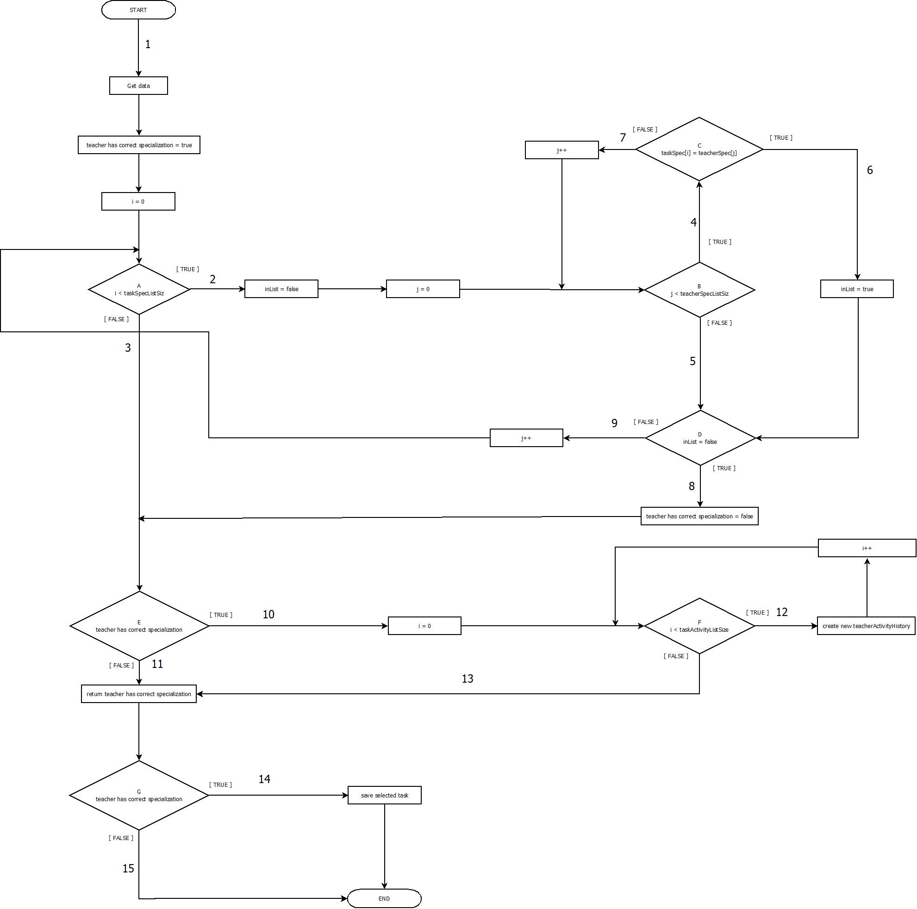

*(Impossible path combinations not displayed)*

|  |  |  |
| --- | --- | --- |
| **Statement** | **Paths** | **Pathcombinations** |
| **A** | in: 1,9 | 1-2 ;**1-3**; 9-2; 9-3 |
|  | out: 2,3 |  |
| **B** | in: 2,7 | 2-4; 2-5; 7-4; 7-5 |
|  | out: 4,5 |  |
| **C** | in: 4 | 4-6; 4-7 |
|  | out: 6,7 |  |
| **D** | in: 5,6 | 5-8; 6-9 |
|  | out: 8,9 |  |
| **E** | in: 3,8 | 3-10; 3-11; 8-10; 8-11 |
|  | out: 10,11 |  |
| **F** | in: 10,12 | 10-12; 10-13; 12-12; 12-13 |
|  | out: 12,13 |  |
| **G** | in: 13,11 | 13-14; 13-15; 11-14; 11-15 |
|  | out: 14,15 |  |

|  |  |  |
| --- | --- | --- |
| **Test cases** | **Paths** |  |
| **1** | 1 - 3 - 11 - 15 | 0 repetitions |
| **2** | 1 - 2 - 4 - 7- 5 - 8 -11 - 15 | 3 repetitions |
| **3** | 1 - 2 - 4 - 6 - 9 - 3 - 10 - 13 - 14 | 1 repetitions |
| **4** | 1 - 2 - 4 - 7- 4 - 6 - 9 - 2 - 4 - 7 - 4 - 6 - 9 - 3 - 10 - 12 - 12 - 13 - 14 | 0 repetitions |
| **5** | 1 - 2 - 5 - 8 -11 - 15 | 0 repititions |

|  |  |  |  |
| --- | --- | --- | --- |
| **Logic test cases** | **Action:**  **Select teacher and task** | **Verwacht resultaat** | **Werkelijk resultaat** |
| **1** | Teacher specialization:  - Java  Task specialization:  - none | Not saved |  |
| **2** | Teacher specialization:  - Java  Task specialization:  - UML  -Testen | Not Saved |  |
| **3** | Teacher  Specialization:  -UML  Task  specialization | Saved |  |
| **4** | Teacher specialization:  -Java  -UML  -Testen  Task specialization:  -UML  -Testen | Saved |  |
| **5** | Teacher specialization:  -None  Task specialization:  -UML | Not Saved |  |

## Process Cycle test

## AssignNCTaskToTeacher/AssignNSCTasktoTeacher

**1. Introduction**

This test will check if the process of assigning a teacher to a task conforms to the relevant use cases. In this document we will specify a test for the process AssignCSTaskToTeacher and AssignNCSTaskToTeacher. Only one test is specified because the process cycle test for both processes is the same.

**2. Process Cycle Test**

1. Decision points & paths

A: in - 1

uit - 2, 3

2. Path combinations

A: 1-2; 1-3

3. Logic test cases

TG-1: 1-2

TG-2: 1-3

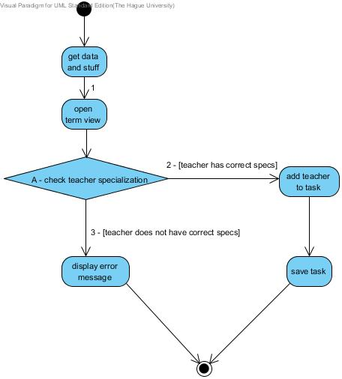

### Real Life Test

Goal:

Gain insight on the understandability of assigning a course specific task to a teacher.

Involved staff:

Testmanager

Team manager(of the HHS)

Preparation:

The entire system should be made available to the team manager. Use the dummy course of the ManageCPM real life test and make 2 more dummy courses (named Course B and Course C) and create 10 dummy teachers (teacher A, teacher B etc) Teachers should have varying working hours (choose randomly). Finally use the term in which the test takes place.

Sidenote:

The real life test for non course specific tasks is identical to this test.

Implementation:

This test is advised to take place simultaneously with other real life tests. After the system has been made available with the dummy data, an email should be sent to the client, who sends it to the team manager.

The email will contain instructions and the following questions and one instruction:

Instruction:

Please assign a course specific task to a teacher first

Questions:

Were you able to perform the action?

Was the way you perform the action immediately clear?

Was the way you performed the action in accordance with your expectations?

Were you satisfied with the way the system showed that your action was performed successfully?

Do you have extra feedback about this action?

The team manager will reply to the email (if necessary the client will forward the reply to the coding team)

Result handling:

the test manager reads the email and assess the answers to form a release advice. The expertise of the test manager will be called upon to evaluate the understandability.

## Real life tests

note NCSTask;

Test has to be performed after the CSTask real life test.

This test is identical to the CSTask real life test, with exception of the instruction in the email to the team leader and the dummies that need to be created:

Preparation:

Create five dummy Non course specific tasks(NT1, NT2 etc), and use the dummy teachers from CSTask Real Life test

Please assign a Non course specific task to a teacher.

The questions will remain the same.

The result handling can be executed the same as the CSTask real life test.